ه



**AS3A**

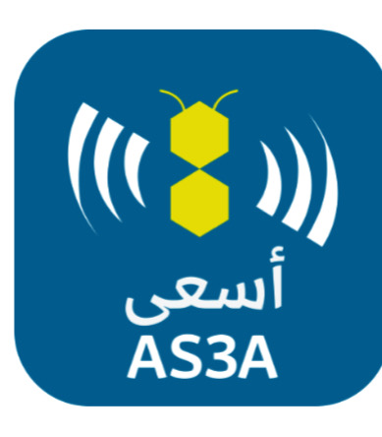

**Members**

Fatima

Munirah

Saja

Galiah

**Table of Contents**

* Summary....................................................... 3
* Methodology used..........................................4
* PlanningPhase…………………………………5
* Gant char.......................................................6
* Project Charter...............................................7
* Feasibility study.............................................8
* Requirements gathering................................9
* Functional/ non-functional ...........................10
* DFD……………………………………………11
* Use Case……………………………………12
* Activity Digram………………………………13
* Class Digram…………………………………14
* Design…………………………………………15

**Summary**

Our project is about the AS3 A platform, approved by the flexible work platform and human resources. It is a program designed to target Saudi ambitious people who seek to search for jobs in their spare time and obtain additional income.  AS3A offers temporary jobs at multiple points of sale and supports ambitious people with rewards By the hour system, the benefit of AS3A is not limited to the ambitious job seekers, but rather doubles the strength of the companies’ performance with flexible work by requesting employees by the hour and eliminating the trouble of registering and following up on employees.

**Methodology used:**

The methodology we used in this project is the SDLC water fall methodology and we used it for the following reasons :

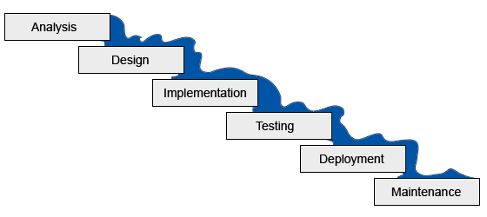

•Our website is not complicated

 • Short and clear AS3A program and project

 • The technology and tools we will use are not dynamic but stable

 • We have available and trained resources

 • AS3A requirements will not change

**Planning Phass**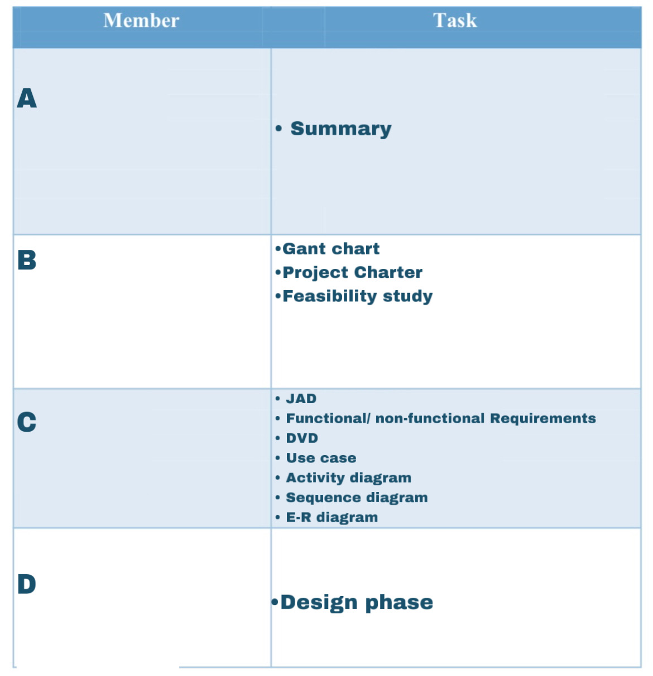

**Gantt chart** :

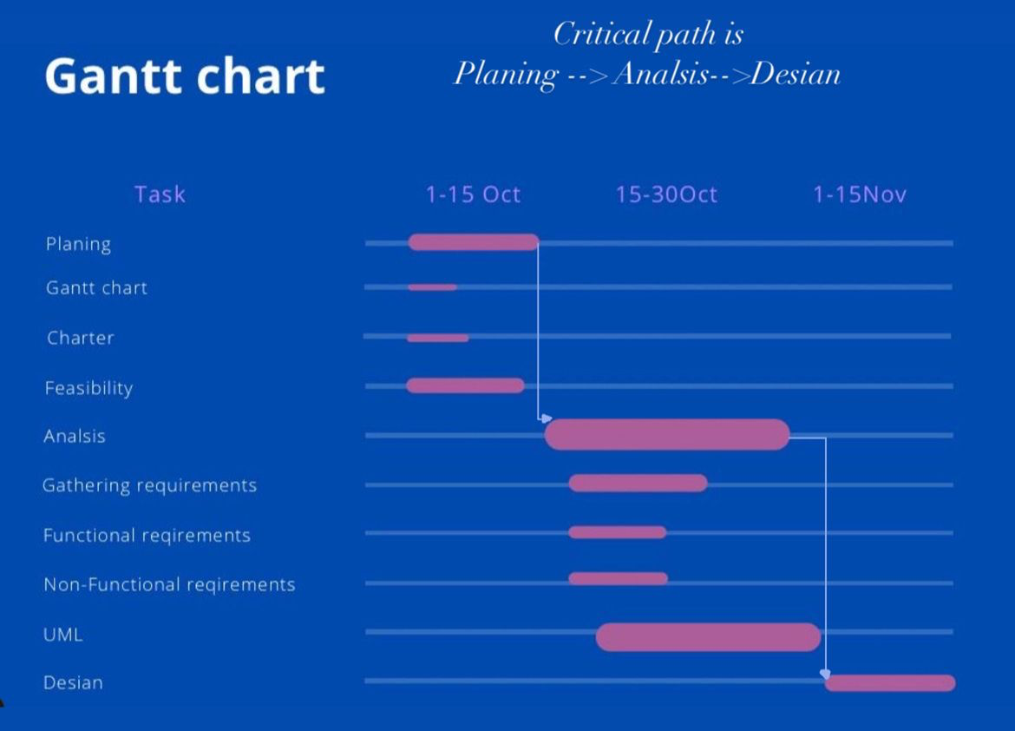

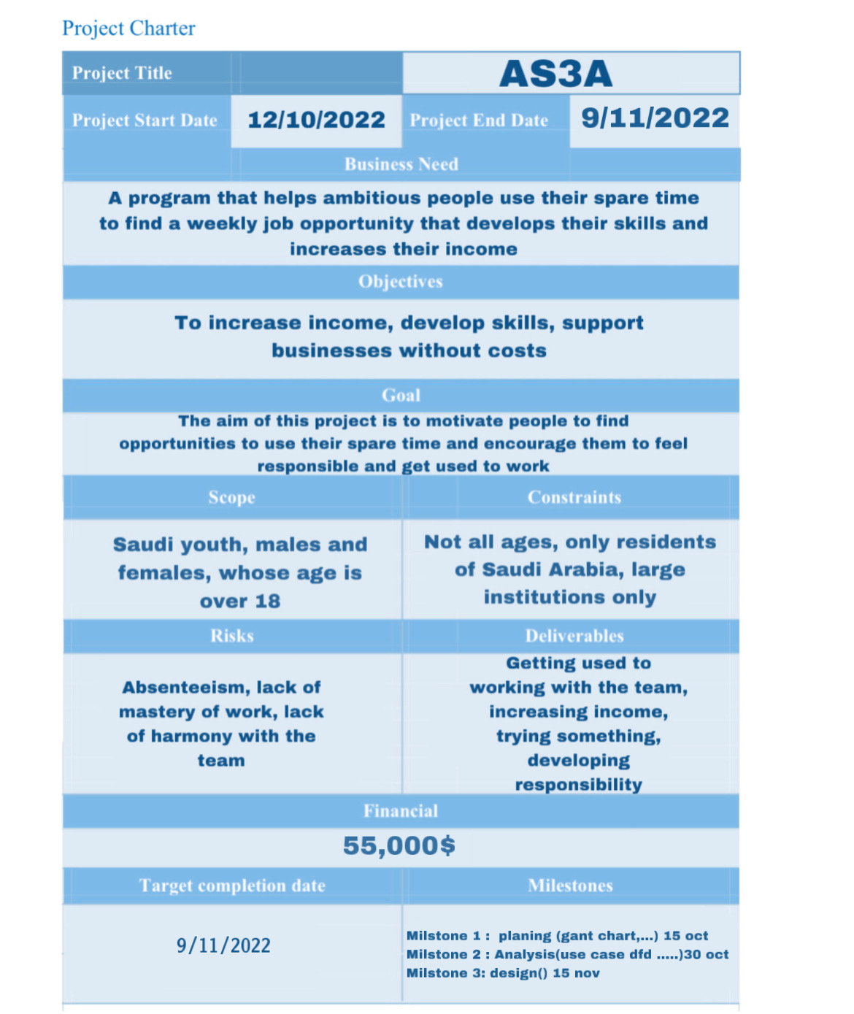

**Feasibility study**

‎‏ Economic feasibility

1- Tangible benefits:

Cost reduction( 10,000)

increase in profit margin(22,000)

Errors reduction(800)

2- Intangible benefits:

Reducing resource consumption (5000)

3- Tangible cost:

Labor cost (15,000)

Operations cost including employee training ( 18,000)

4- In Tangible cost

customer goodwill

Employee morale

5- One-time costs:

User training ( 18,000)

Program preparation (33,000)

6- Recurring cost:

system maintenance (9000)

‏Operational feasibility:

‏The application solves problems and is useful and helps and facilitates obtaining jobs in an orderly and easy way

Scheduling feasibility

The project meet the organizational deadlines with very high probability.

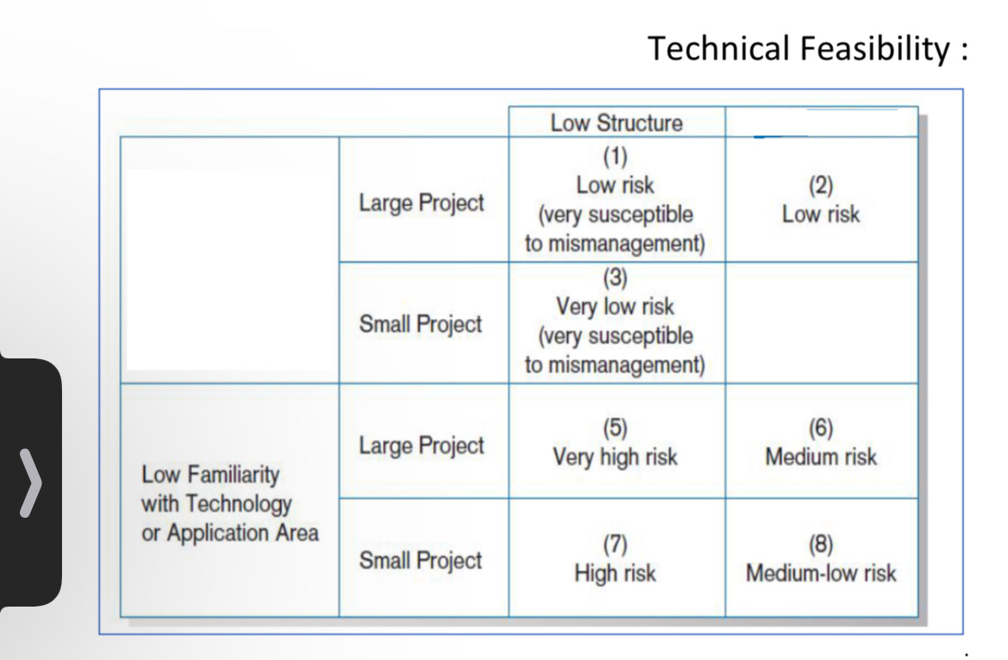

Requirements gathering

Analysis Phase

Requirements Gathering

The method used in the process of collecting requirements is monitoring by observing the user as he takes the necessary measures to choose his appropriate job

Functional Requirements:

user functional requirements

1-register

1.1The user can create a new account on the app

The user can add his personal information.name,ID number,date of birth,card expiry date,e-mail,city,gender.

1.2The user can enter his CV.personal biography,academic level add experiences,add certificates.

1.3The user can enter the banking information. Full name,IBAN account number, bank name.

1.4The user can choose the appropriate fields of work.

1.5The user can choose the working periods (morning/evening)

2- log in

2.1 user can log into the application by entering the mobile number and password.

2.2The user can reset the password.

3- job Application

3.1The User can select job to view job description.

3.3 the user can agree to the terms and conditions.

4- Response

4.1the User arrival of acceptance or rejection

company functional requirements.

1-job

1.1the company can view Job Application

1.2 the company can Update on the job

1.3 the company can add job

1.4 the company can send response acceptance or rejection

Non-functional Requirements:

1. Performance:

. The app load time must be less than seven seconds.

. The system should receive updated information every half an hour .

. The application should be Available for use 24 hour .

2. Usability:

. The system should be easy to use

3. Security and privacy:

. This system should protect user data.

4. Operational:

. The application must be operated on android and iO

DFD context

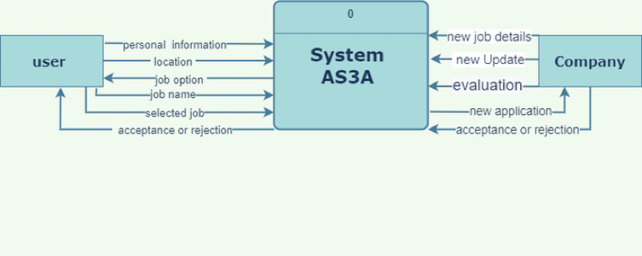



DFD Level-0

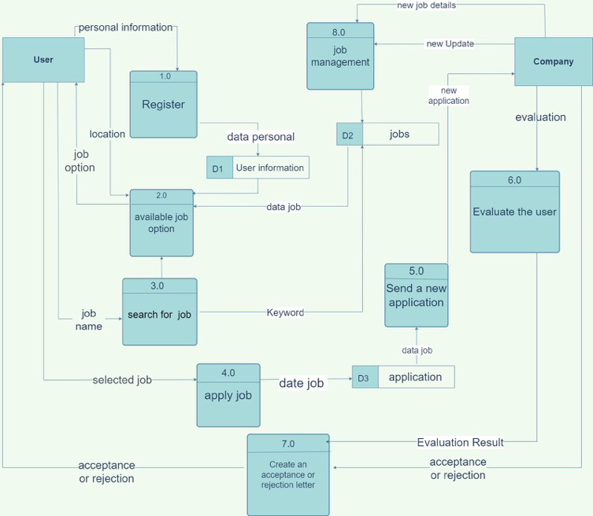

DFD-level 1

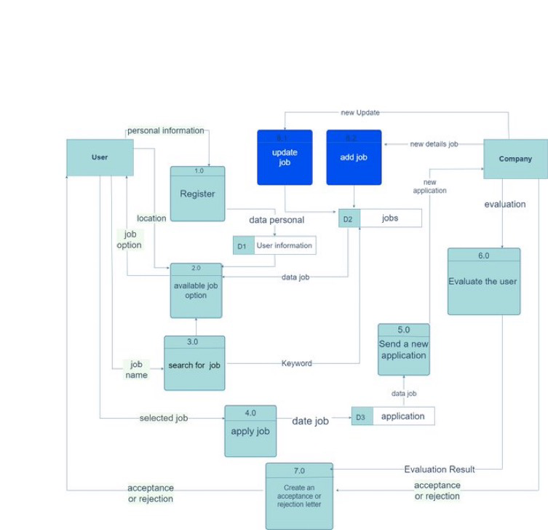

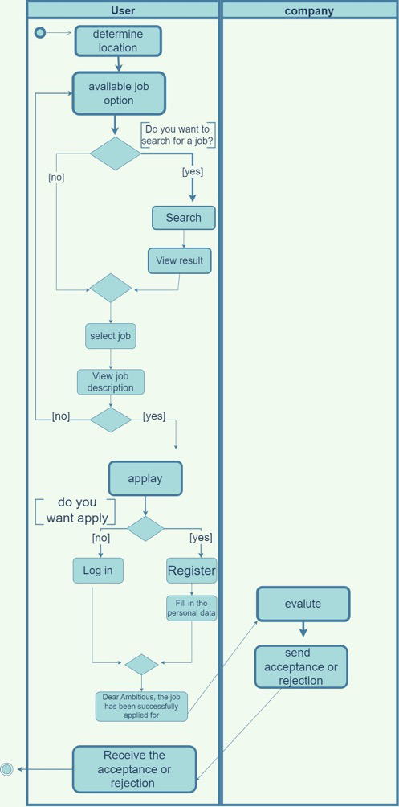Activity Diagram

Use case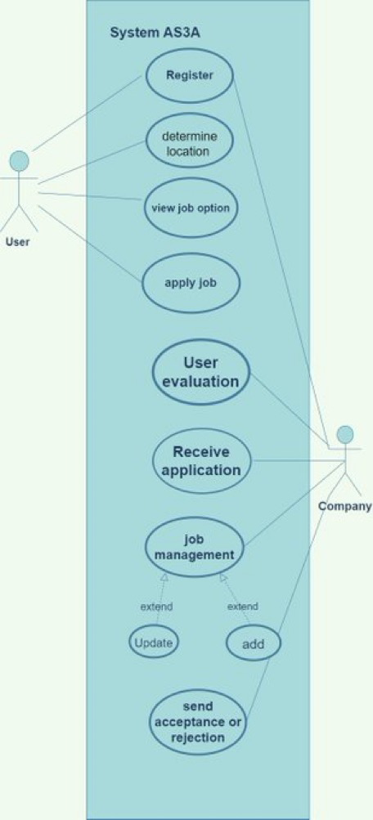

Class digram

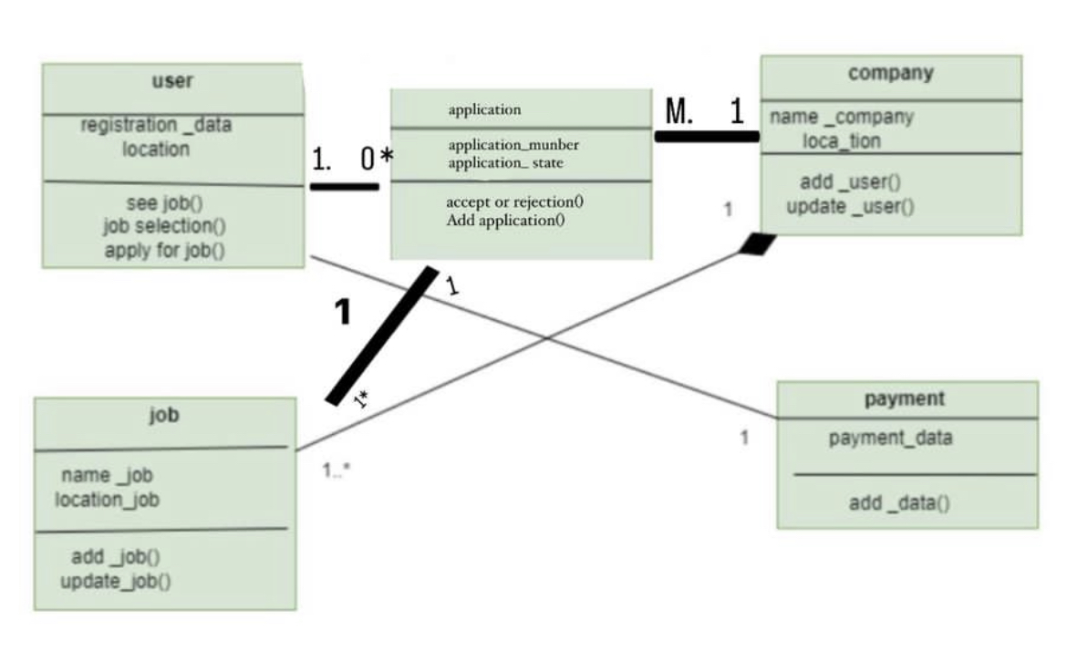

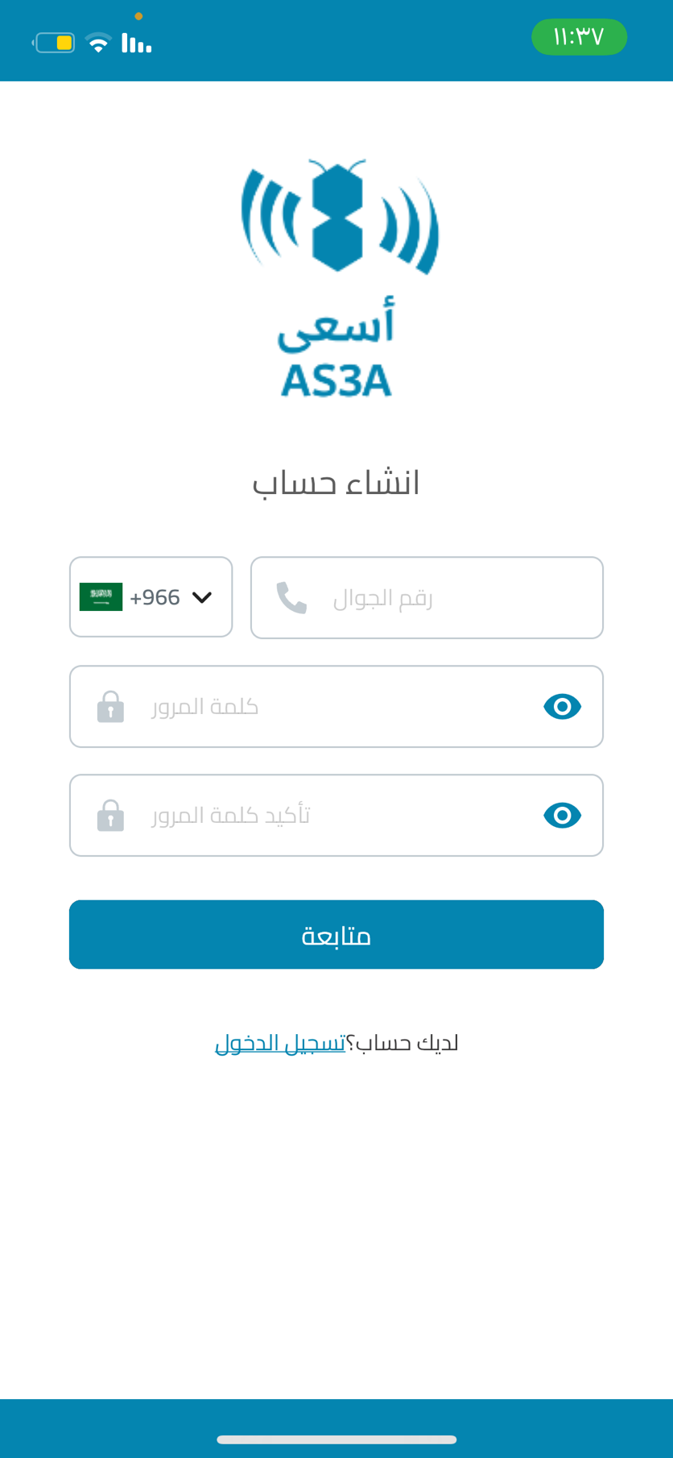Design :

1-Register

1. 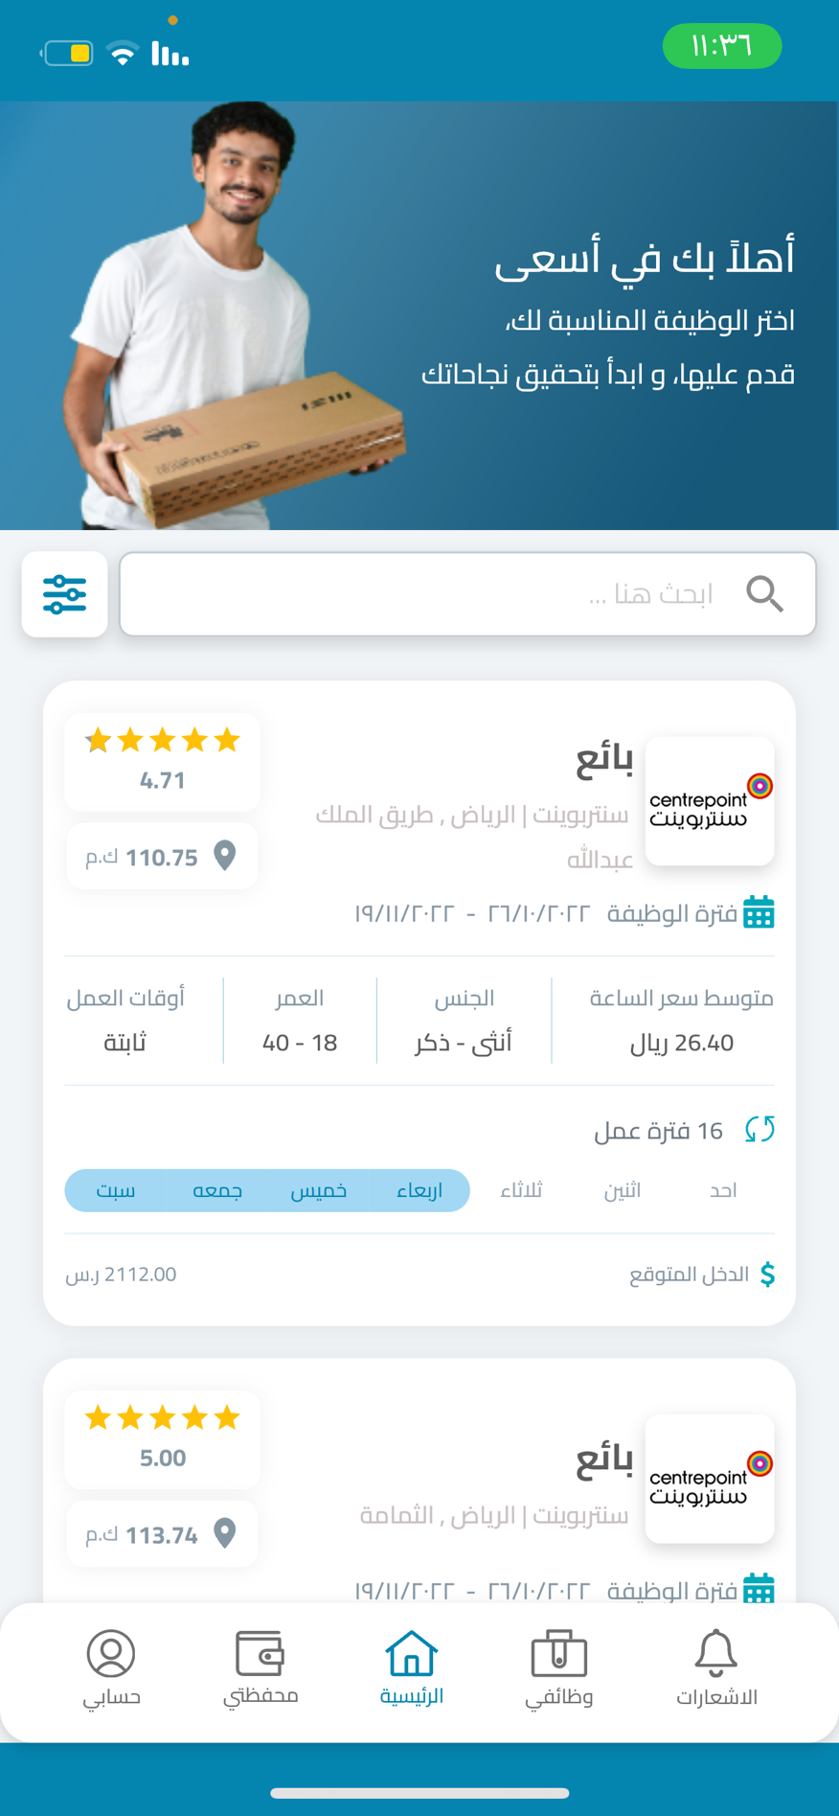 View job
2. 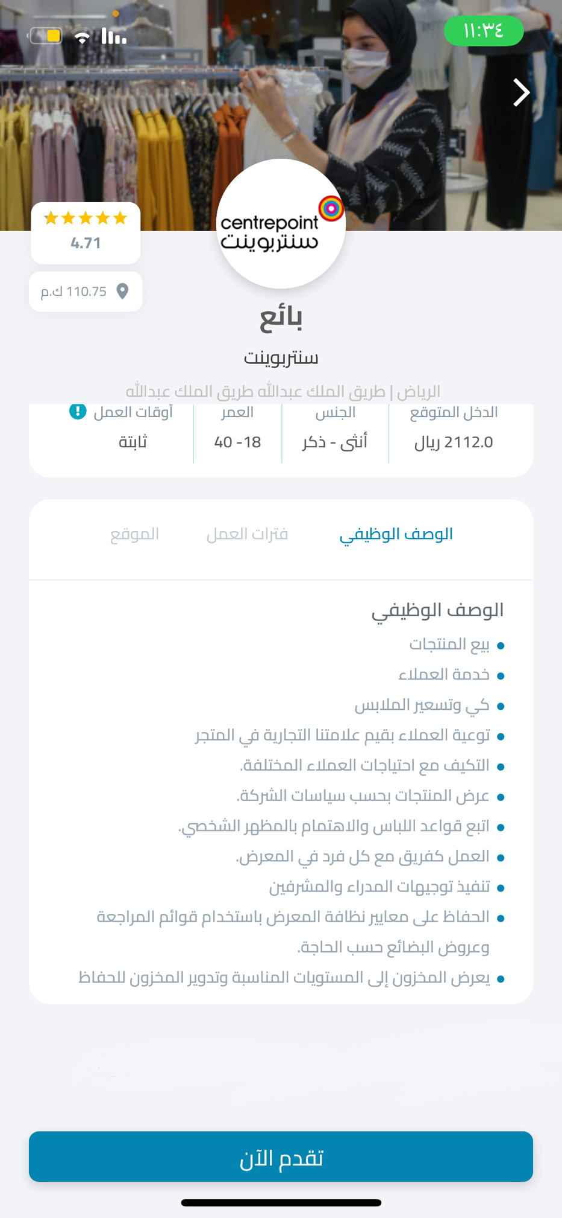 Select Available Job
3. 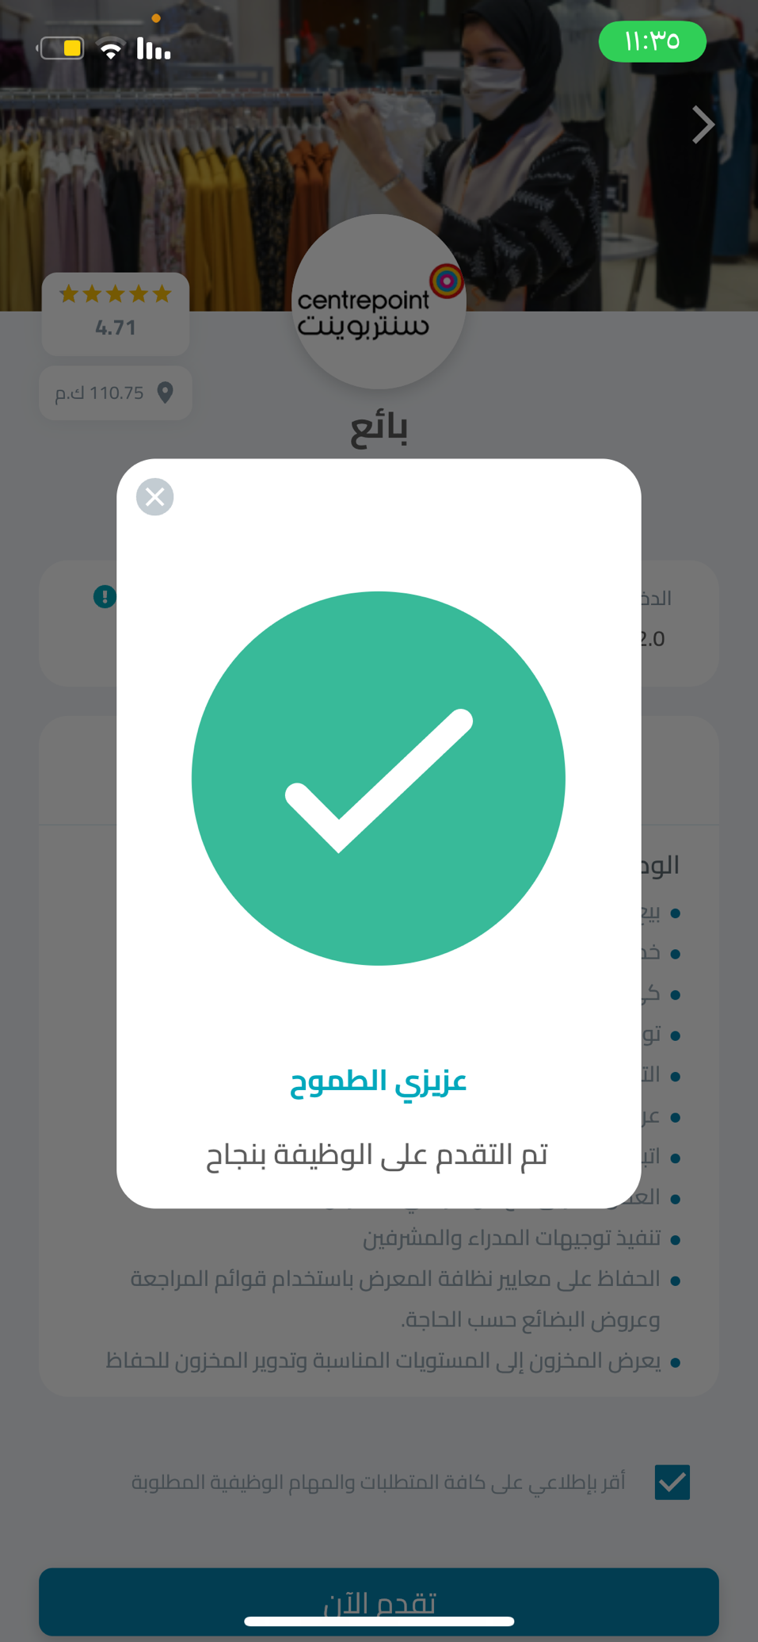Acccept